AULTMAN HEALTH
I13 Health Quest Patient Refund
Inbound/Outbound Interface (Healthquest -> FSM)

Document Properties
Author | Paolo Enrico Vicente, Daryll Blu Papellero
Creation Date | 08/09/2023
Last Updated
Document Reference | ANA-050 + DES-020
Version | 1.0

Document Control

Change Record
1
Date | Author | Version | Change Reference
08/09/2023 | Paolo Enrico Vicente | 1.0 | Initial draft: Executive Summary, Functional Specification,
MM/dd/yyyy | <Technical Resource> | 1.1 | Initial draft: Technical Specifications (Solution Overview)
MM/dd/yyyy | <Functional Resource> | 1.1 | Submitted for client approval
MM/dd/yyyy |  | 1.1 | Client approved version
MM/dd/yyyy | <Functional Resource> | 2.0 | Modified approver notification verbiage (FR 1.5)

Contents
1 Document Control 2
1.1 Change Record 2
2 Executive Summary 4
2.1 Business Objectives 4
2.2 Assumptions 4
3 Functional Specifications 5
3.1 Overview 5
3.2 Functional Requirements 5
3.3 Business Process Flow 6
3.4 Field Mapping 6
4 Technical Specifications 7
4.1 Solution Overview 7
4.2 Technical Configurations 7
5 Testing Process 15
6 Signature 17
6.1 Functional Specification 17
6.2 Technical Specification 17
7 Appendix 18
7.1 Client Approval 18
7.2 Sample Vendor Files 18
7.3 LPL Codes 18
7.4 Process Flow 18

Executive Summary
Aultman Health Foundation (AHF) has a business relationship with Healthquest who submits its Patient refund Transaction file and process the payment in Infor CloudSuite Financials via Cash Management Module.
This document describes the functional requirements to import the Patient refund Information from Healthquest and Upload the file to Infor CloudSuite Financials. After the payment has been processed, an outbound notification file will be created and send the back file to HQ.

Business Objectives
This Inbound/outbound interface intends to change the process by extracting FSM master data and transactional data and transmit/load it into the Strata Module for Aultman’s consolidated reporting and reconciliation of payment.

Assumptions
This specification assumes that the following statements are true. Any changes can result in a change order and will be managed using the change order process as defined in the Service Workorder.
- The inbound interface file will be generated by Healthquest and converts the information to FSM format/template. The outbound file for payment will be generated by FSM, convert the payment file before placing it into Aultman’s SFTP.

- No crosswalk in accounts or any finance dimensions will be used. All accounts are one to one relationship.
- File naming convention will be provided by AHF for the outbound file for each of the files. Details will be provided in sub section below.

- Files will be imported /extracted and placed to a designated SFTP location where FSM will consume.

- File archiving will be moved automatically to the designated location by Aultman team for both Inbound file and Outbound file.

Functional Specifications

Overview
The Inbound and Outbound interface will address Aultman’s requirement to process Patient Refunds from Healthquest to FSM Cash Management module and process payment via FSM AP module. Once payment has been processed, an outbound payment file will be created and submitted to the bank and a file will then be sent back to HQ for reconciliation.

Functional Requirements

Functional Requirement ID | Requirement Definition
FR 1.1 | Healthquest to send patient refund file (header file, distribution file). Infor IPA will consume the file and convert to cashledgerpayment import format.
FR 1.2 | The converted file will be imported to FSM’s cashledgerpayment import business class and run interface.
FR 1.3 | Interface Delivery Method
FR 1.4 | Send email notification to AP team for errors and / or successful interface
FR 1.5 | File archiving will be moved automatically to the processed folder.

- File import and conversion
Source files will be saved in assigned SFTP location, then IPA will pick up the file and convert it to an FSM format that will be acceptable for CashLedgerPaymentImport business Class.

- FSM to consume the converted file
The converted file will then be placed in the CashLedgerPayment Business Class.
Cash Management > Cash Ledger Processing > Process Cash Ledger > Interface Cash Ledger Transactions > Payment Interface Maintenance
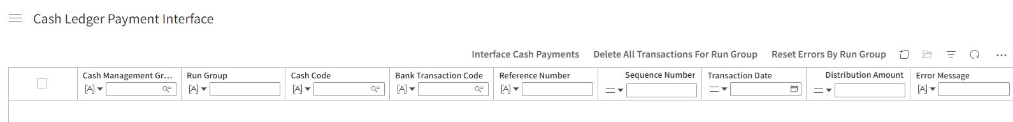

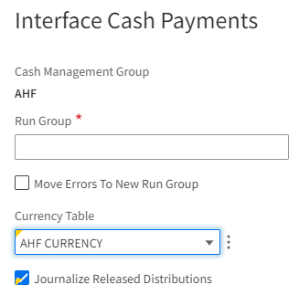

- interface delivery method
Interface Type | Inbound
Source System | Third Party Application (HealthQuest)
Target System | Client FTP/SFTP location
Frequency | Weekly (Friday) 830 AM ET
Trigger | File Channel
File Location | sftp.aultman.com
File Name | Aultman_Refund_MMDDYYYY
File Format | Flat File
Input File Location to AHF SFTP | \\ahf2000.aultman.com\dfs\Department\Dnload\PROD\Lawson\PatientRefunds  Sourcefilename:REFREQ AND REFDIS (Should be SFTP)
Archive Input File Location to AHF SFTP | \\ahf2000.aultman.com\dfs\CorporateFinance\Finance\FTPFiles\AP  REFREQ.YYYYMMDD and REFDIS.YYYYMMDD (Should be SFTP)
Archive Output File Location to AHF SFTP | /Inbound/PatientRefund/Processed/<YYYY>/<Month>  Not needed
Archive File Name | Aultman_Refund_MMDDYYYY

- Email Notification
An email notification will be sent to AP Team (Aultman) notifying that the file was successfully imported and saved in its assigned sftp location.

To | Accounts.payable@aultman.com
Cc
From | FSM_notification@infor.com
Subject | Patient Refund – Aultman_Refund_MMDDYYYY
Body Text | Dear AP Team,  Patient Refund file with RunGroup < PREFMMDDYY > has been successfully interfaced.  Thank you
With Error Email
To | Accounts.payable@aultman.com
Cc | BOSTeam@aultman.com
From | FSM_notification@infor.com
Subject | Patient Refund – Error + Run Group
Body Text | Dear AP Team,  Interface error occurred during Payment Interface. See below details:  WorkUnit: XXXX  RunGroup: PREFMMDDYY  Please resolve the error message and re-run the same run group.  Thank you

Another email notification will be sent if no files were scanned or available during the scheduled file scanning.

To | BOSTeam@aultman.com
Cc
From | FSM_notification@infor.com
Subject | Patient Refund – No files available for scanning
Body Text | Dear BOSTeam,  FSM has tried to import the file for patient refund but no files are available for scanning.  Please upload the file and scan manually.  File Location: \\ahf2000.aultman.com\dfs\Department\Dnload\PROD\Lawson\PatientRefunds  Sourcefilename:REFREQ AND REFDIS  Thank you

- processed file to be archived
Processed files will be move automatically to the processed folder.

Business Process Flow
Legend:
Process outside FSM / Manual process
IPA driven

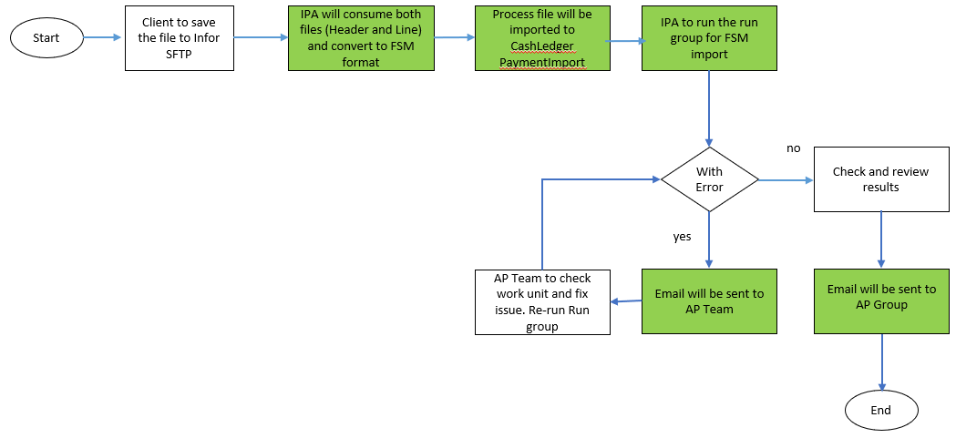

Field Mapping

Field Mapping for CM Refund inbound interface

CashLedgerPaymentImport Business Class

Source Field Name (Inbound) | FSM Field Name | Size | Type | Remarks
 | CashManagementGroup |  |  | HardCoded = AHF
 | CashLedgerPaymentImport.RunGroup |  |  | PREFMMDDYY
H. CVI-CASH-CODE | CashLedgerPaymentImport.CashCode |  |  | See mapping below table
 | CashLedgerPaymentImport.BankTransactionCode |  |  | HardCoded = PAR
H. CVI-COUNTRY | CashLedgerPaymentImport.ReferenceNumber |  |  | Include leading zeroes
 | CashLedgerPaymentImport.SequenceNumber |  |  | Starts 1 with increment of 1
 | CommentText |  |  | Blank
 | PayablesData.PayablesCompany |  |  | HardCoded = 10
 | PayablesData.Vendor |  |  | HardCoded = 123
 | PayablesData.PayGroup |  |  | HardCoded = AHF
H. CVI-POSTING-STATUS | Status |  |  | 0 – Unreleased  1 – Released
H. CVI-INVOICE-DTE | TransactionDate |  |  | MM/DD/YYYY
H. CVI-DESCRIPTION | Description
H. CVI-VENDOR-VNAME | PayeeName
H. CVI-INVOICE | MailingName
 | PayeePostalAddress.Country |  |  | Hard Coded = US
H. CVI-ADDR1 | PayeePostalAddress.DeliveryAddress.AddressLine1
H. CVI-ADDR2 | PayeePostalAddress.DeliveryAddress.AddressLine2
H. CVI-ADDR3 | PayeePostalAddress.DeliveryAddress.AddressLine3
H. CVI-ADDR4 | PayeePostalAddress.DeliveryAddress.AddressLine4
H. CVI-CITY-ADDR5 | PayeePostalAddress.Municipality
H. CVI-STATE-PROV | PayeePostalAddress.StateProvince
H. CVI-POSTAL-CODE | PayeePostalAddress.PostalCode
H. CVI-COUNTY | PayeePostalAddress.County
 | PayeePostalAddress.Type |  |  | HardCoded = 2
H. CVI-INV-CURRENCY | BankCurrency
H. CVI-TRAN-INV-AMT | DistributionAmount
 | Reference |  |  | Blank
 | TaxCode |  |  | Blank
 | TaxableBankAmount |  |  | Blank
 | GeneralLedgerSourceCode |  |  | HardCoded = AP
 | ProcessLevel |  |  | HardCoded = 10PA
 | TaxID |  |  | Blank
 | ReportableIncomeAmount
 | TaxIDType
 | PayTaxExempt
 | DistributionAccount.Ledger |  |  | HardCoded = CORE
L. CVD-DIST-COMPANY | DistributionAccount.ToAccountingEntity |  |  | Remove leading zeroes. Must be 2 digit
L. CVD-DIS-ACCOUNT | DistributionAccount.GeneralLedgerChartAccount
L. CVD-ACTIVITY | DistributionAccount.Project
L. CVD-DIS-ACCT-UNIT | DistributionAccount.FinanceDimension1
 | DistributionAccount.FinanceDimension2
L. CVD-ACCT-CATEGORY | DistributionAccount.FinanceDimension3
 | DistributionAccount.FinanceDimension4
 | DistributionAccount.FinanceDimension9
 | DistributionAccount.FinanceDimension10
 | InterfaceAsPosted |  |  | FALSE
H. CVI-VENDOR-VNAME | PayeeFirstName
 | PayeeMiddleName
 | EmailAddress
 | UnitsAmount

Mapping for Cash code

Process Level | Cash Code
10 | 6667
67 | 9120
33 | 7128
83 | 453

Sample Inbound File:
Header (REFREQ) and Distribution File (REFDIS)

Mapping File of Source

Technical Specifications

Solution Overview
The integration between Client to Infor comprises of the following steps:
- The source file will be placed on the sFTP Directory.
- The File Channel daemon will invoke the Infor Process Automation solution (IPA).
- The IPA will load the source file into the staging business class in FSM environment.
- The IPA will trigger the interface program to move the data from the staging business class to the solution business class when the source file has been imported successfully.
- The IPA will send notification of failure to identify recipients based on the following:
  - DBImport result
  - Interface program result

Technical Configurations

Process Flow Design
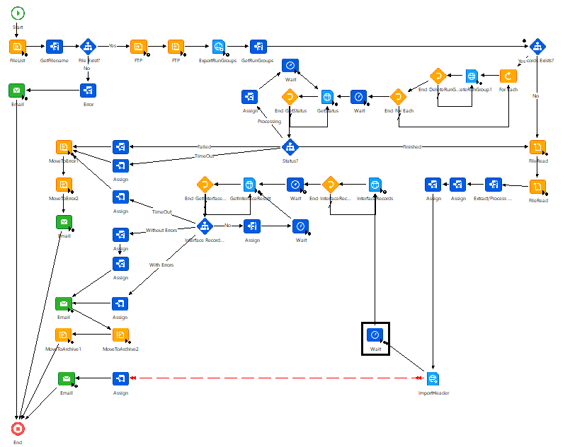

System Configuration Setting

<System Configuration Set>

Properties
Property Name | Value | Description
AH_HealthQuestPatientRefund_SourceDirectory | /Inbound/PatientRefund | Directory where input file will be read
AH_HealthQuestPatientRefund_ArchiveDirectory | /Inbound/PatientRefund/Processed | Directory where input file will be archived
AH_HealthQuestPatientRefund_ErrorDirectory | /Inbound/PatientRefund/Error | Directory where input file will be archived when error is encountered
AH_HealthQuestPatientRefund_LogDirectory | /Inbound/PatientRefund/Logs | Directory where log files are archived
AH_HealthQuestPatientRefund_BOSTeam | <email> | Default: BOSTeam@aultman.com
AH_HealthQuestPatientRefund_APTeam | <email> | Default: Accounts.payable@aultman.com
emailFrom | noreply@inforcloudsuite.com

File Transfer Connection
Host | sftp.inforcloudsuite.com
Protocol | SFTP (Port 22)
User | trn: ***** _tam_trn-usr  prd: ***** _tam_prd-usr
Password | *****
File Location | /Inbound/PatientRefund
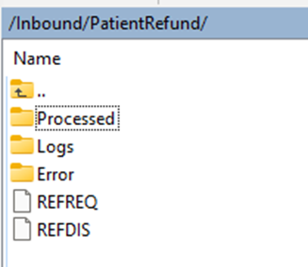

Testing Process
NOTE: Applicable only if not using TES-060.

- <Requirement Definition Narrative>
Scenario | Expected Result
<Scenario Description> | <Expected result narrative>

- Cross Reference Table
Scenario | Expected Result
Create a record | User successfully created a record.
Delete a record | User should not be able to delete a record.

- Interface Delivery Method
Scenario | Expected Result
Valid file/s uploaded | - Header file picked up by File Channel for processing.  - IPA is triggered via File Channel (work unit generated).  - All related files are processed accordingly.  - Data is imported to correct staging business class/es.  - Data is interfaced to related solution business class/es.  - Source file/s are moved to processed directory.  - Import log/s are moved to processed directory.  - Email notification sent to specified recipient/s.
Invalid header file uploaded: incorrect file name | - Header file not picked up by File Channel.  - No work unit generated.
Invalid file/s uploaded: incorrect file header | - File is processed via IPA.  - No data imported to the staging business class.  - Successfully imported data for related staging business class/es are deleted.  - Inteface program is not triggered.  - Source file is moved to error directory.  - Import log is moved to error directory.  - Email notification sent to specified recipient/s.

- Error Handling
Scenario | Expected Result
<Scenario Description> | <Expected result narrative>

- Approver Notification
Scenario | Expected Result
Trasaction has been final approved. | Email notification sent to specified recipient.

Signature
NOTE: Applicable only if not using any approval trackers ex. IPON, JIRA.

By signing this document both Infor and <Client> agree and confirm their acceptance of information contained within this specification which encompasses detailed business processes, requirements, scope and solution design.

Functional Specification

Project Sponsor | Name | Position | Date | Signature
<Client>
Infor

Technical Specification

Project Sponsor | Name | Position | Date | Signature
<Client>
Infor

Appendix

Client Approval

Sample Vendor Files

LPL Codes

Process Flow

